Lab Contents
This lab purpose is to install and use MondoRescue to produce a golden image of a server and restore it.

Lab Writer and Trainer
Bruno.Cornec@hp.com
Lab – MondoRescue

Table of content
Objectives 2
Reference documents 3
Environment setup 3
MondoRescue installation 3
Bare metal Disaster Recovery with Mondo Rescue 4
Disaster Recovery (DR) Set Creation 4
Bare Metal Recovery on another system (with iLO Virtual Media) 14
Bare Metal Recovery in KVM/QEMU (aka P2V) 14
Network based Disaster Recovery 17
Disaster Recovery (DR) Set Creation 17
Network based Bare Metal Recovery (with PXE) 17
SSSTK usage with Mondo Rescue 17
Disaster Recovery (DR) Set Creation 17
Bare Metal Recovery (with PXE) 18

Overview of the MondoRescue Lab

Objectives
At the end of the Lab students should be able to install MondoRescue, use mondoarchive to create a golden image of a server and boot from it to res tore with mondorestore on a target..
Expected duration : 100 minutes

Reference documents
When dealing with the installation and configuration of MondoRescue, the first approach is to look at some reference documents:
The HOWTO at http://www.mondorescue.org/docs.shtml as well as man pages
The Wiki at http://trac.mondorescue.org/wiki and especially the FAQ at http://trac.mondorescue.org/wiki/FAQ
Most of the documentation is provided currently under a wiki format, so contributors are welcome and expected, including those finding issues in that training material. Trac also provides a bug report/enhancement request feature ;-)
A mailing-list dealing with MondoRescue is available at http://sourceforge.net/mailarchive/forum.php?forum_name=mondo-devel
Estimated time for the lab is placed in front of each part.
Environment setup
Estimated time: 10 minutes
MondoRescue installation
Mondorescue is available externaly from ftp://ftp.mondorescue.org/ and internally on the HP LAN from http://eurolinux.grenoble.hp.com/pub/linux/mondorescue/ or using ftp as well from the same place.
Version 2.2.9.1 is the current stable release. Version 2.2.10 is the development version
Here is the table of corresponding versions:
Tools | MondoRescue 2.2.9.1 | MondoRescue 2.2.10
mondo | 2.2.9.1 | 2.2.10.0
mindi | 2.0.7.1 | 2.0.8
mindi-busybox | 1.7.3 | -

You may want to use yum to do the installation. For that, download the file under rhel/5 named mondorescue.repo and place it under your /etc/yum.repos.d directory. Of course, you can use rpm and deal with the dependencies yourself ;-)
You'll also need for RHEL additional packages not provided in the base distribution, but which are brought by RPMforge (or EPEL). So create the following file:
# cd /etc/yum.repos.d/
# wget ftp://eurolinux.gre.hp.com/pub/linux/mondorescue/rhel/5/mondorescue.repo
# cat > /etc/yum.repos.d/rpmforge.repo << EOF
[rpmforge]
name = Red Hat Enterprise $releasever - RPMforge.net - dag
baseurl = ftp://eurolinux.gre.hp.com/pub/linux/rpmforge/redhat/el5/en/x86_64/dag
enabled = 1
gpgcheck = 0
EOF

Then use yum to install the application with all its dependencies and check that the correct version is installed and operational:
# yum install mondo.x86_64
# man mondoarchive
From now on, the Lab is “à la carte” ;-) Which means you cant take one of the following part at will and try to do it, once you've done at least the Disaster Recovery Set Creation. Estimated time is placed in front of each part.
I recommend that if you don't already know mondorescue you do at least the PXE as it's the simplest and quickest. The iLO is simple as well but longer. Then look at P2V, SSSTK. Those of you feeling more adventurous, or already knowing the tool, may want to help debug 2.2.10 and use it in their Lab. Bug reports welcome ;-)
Bare metal Disaster Recovery with Mondo Rescue
Estimated time: 20 minutes – Based on mondo 2.2.9.1, current version.
Disaster Recovery (DR) Set Creation
The goal of this part is to make a DR Set of media under the format of ISO images of 4GB of your server. Use for that simply the mondoarchive command:
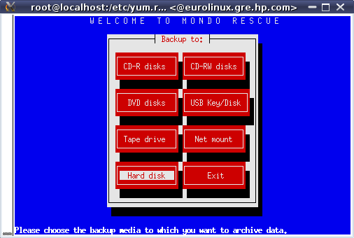
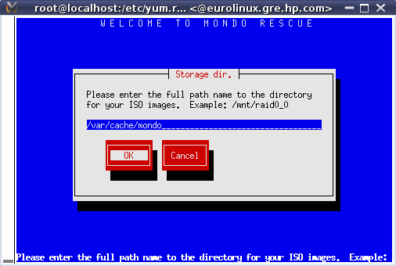
That's where you ISO image will be created at the end. Note that mondo needs room to make that image, which is currently taken were there is the largest place available.
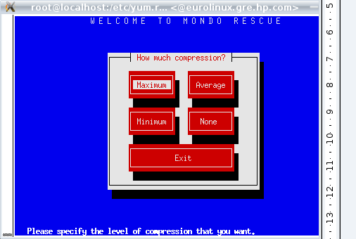
Compression is done by default using bzip2 with that version. Another compressor can only be chosen when using the CLI and options -G (gzip) or -L (lzo) or -Y (lzma) in 2.2.10.
Specify the size of your image (could be larger than a physical media if you do not intend to really burn it).
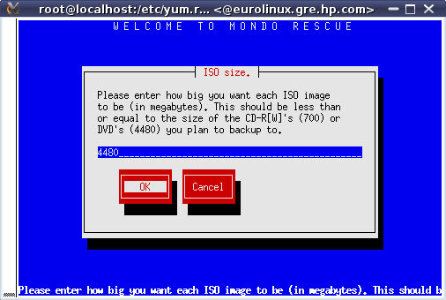
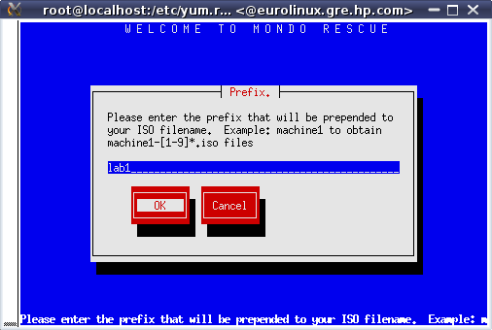
The prefix name allows you to keep multiple images in a central repository for example.

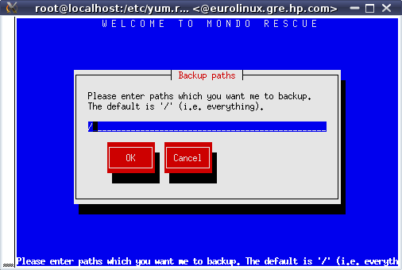
You have to use / for a disaster recovery solution for your include dir.
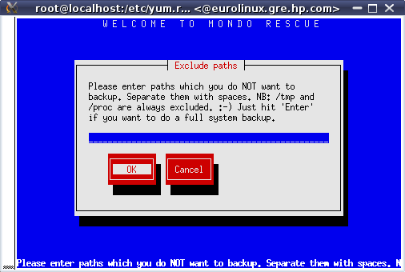
In order to have a quicker backup, you may want to exclude some useless path (they may be backed up with another tool, which is often the case of data or databases). Advise here is to not exclude what would break the coherency of your package system.

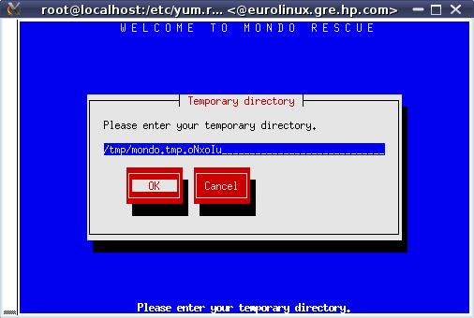
You may now precise where you want your temporary files to be generated (file system having the most place is the default) They are usually not big in size
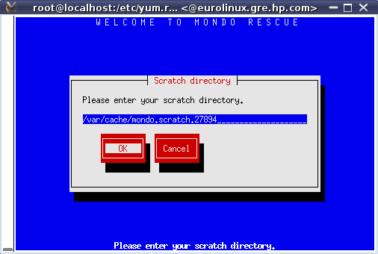
.
You may now precise where you want your scratch files to be generated (file system having the most place is the default). They will occupy the size of a media so choose with care.
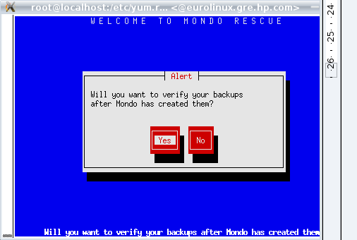

At the end of the archiving run, mondo may optionaly verify all the sets created to check their consistency. Of course it takes more time.
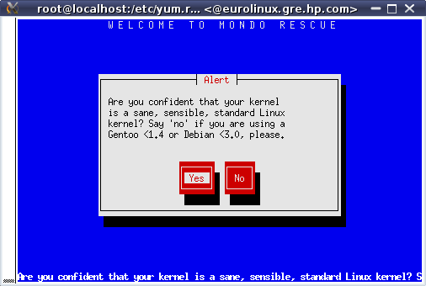
With recent versions of mondo you should alwys say yes here. Even with a Gentoo or old Debian distribution. This message will disappear in 2.2.10.
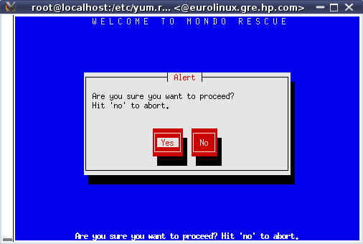

Fire !
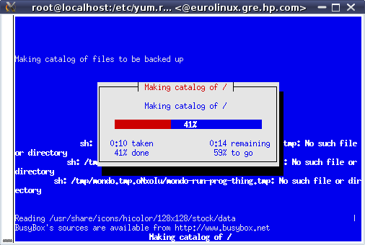
Mondo first creates a catalog of all files to handle.
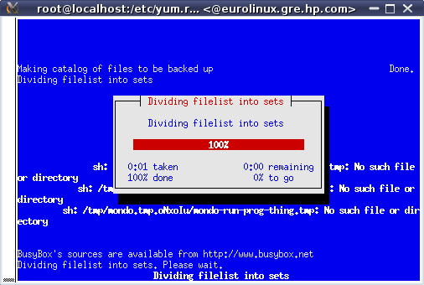

Then it splits those files in various sets to be created.
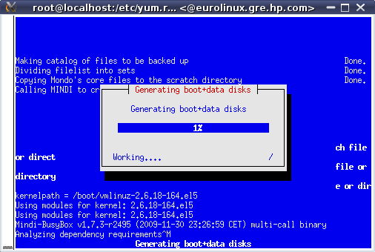
Then mondo calls mindi which generates the boot environment which will be used at restore time to prepare the machine (modules loading, device creation, partitioning, lvm management, ...)
Now it's time to create all the DR sets.
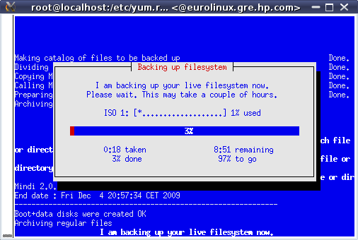
During that phase, you may want to have a look at the documentation on tools provided with this Lab.
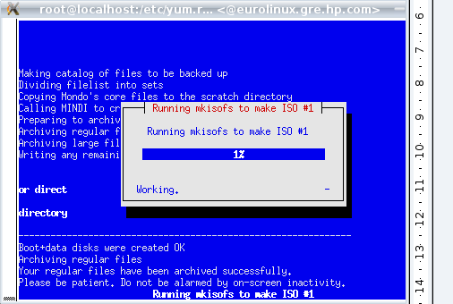

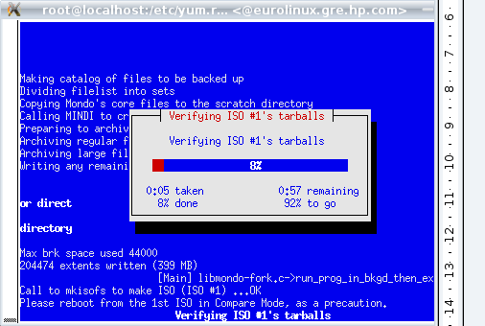
The verification of ISO is done upon previous request.
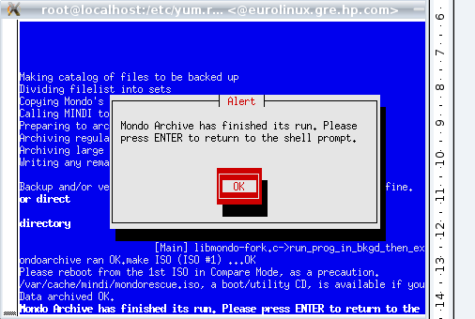
That's all folks !
[root@localhost yum.repos.d]# ls -l /var/cache/mondo/
total 409368
-rw-r--r-- 1 root root 11 Dec 4 20:55 difflevel.0
-rw-r--r-- 1 root root 418762752 Dec 4 21:00 lab1-1.iso
Bare Metal Recovery on another system (with iLO Virtual Media)
Estimated time: 20 minutes
In order to have optimal throughput, use a browser on your system to access the OA of the target machine. Mount the produced ISO image with the virtual media of it, and restore your initial content on it.
You should have nothing special to do except accept it takes much more time than using a physical real media due to the USB emulation provided by the iLO virtual media.
You may want to try to change some parameters to see how mondorestore deals with it. You may remark that LVM modifications are not easy today, and require to edit the /tmp/i-want-my-lvm script. This is expected to be improved in January 2010.
Bare Metal Recovery in KVM/QEMU (aka P2V)
Estimated time: 30 minutes
For this part, in addition to the above mentioned documentation, please refer to the excellent manual provided by Lester Wade at http://www.mondorescue.org/docs/p2v.pdf.
Now you can try to see if you can re-install the image of your system just like that on a KVM Virtual Machine.
You first need some additional packages. Then you'll need to create an empty virtual machine. To do that derive the following command:
[root@localhost ~]# yum install kvm kvm-qemu-img
[root@localhost ~]# ln -sf /usr/libexec/qemu-kvm /usr/bin/kvm
[root@localhost ~]# modprobe kvm-intel
[root@localhost ~]# mkdir -p /home/vm
[root@localhost ~]# qemu-img create -f qcow2 /home/vm/img.qemu 130G
where 130 is the number of GB to allocate for the VM, which should correspond to the original disk size. The space will only increase as the VM is used.
You can now use the MondoRescue image to initiate your virtual machine with KVM. So type a command similar to the following:
[root@localhost ~]# kvm -cdrom /var/cache/mondo/lab1-1.iso -m 512 -boot d /home/vm/img.qemu
It will launch the VM and boot on the CD which is associated with your MondoRescue image, thus beginning the installation. 512 is the size of the RAM in MB, that you may adapt at will.
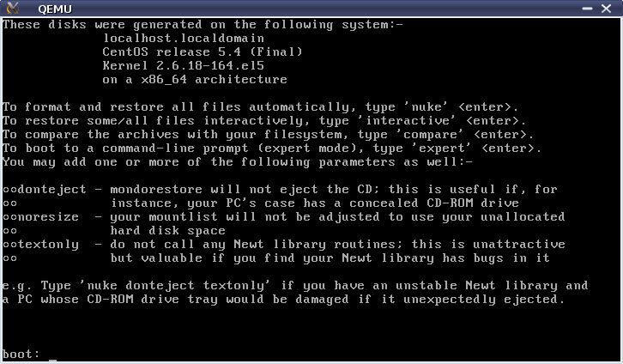
Choose automatic mode to restore. It should fail.
You'll have to adapt the mountlist as hard disk device names are different (/dev/sda => /dev/hda)
Then continue by trying to restore your content using that new mountlist.
However, it will still not work as you'll see, as we were using LVM and that LVM configuration uses the old device names as well, but can not be changed through the interface. So after the error message concerning the formating of the File Systems which aborts, change terminal (ALT-F2) and do the following:
:
# perl -pi -e 's/sda/hda/' /tmp/i-want-my-lvm
# perl -pi -e 's/sda/hda/' /tmp/mountlist.txt
Then relaunch mondorestore and this time use the interactive mode.
All those tasks have to be done, as we are changing fundamentally the underlying hardware of our system. However, the tool supports it, providing some adaptations. As seen earlier, the DR on the same hardware is strait forward. An enhancement request exists in trac to have a more automatic support of cloning on different hardware.
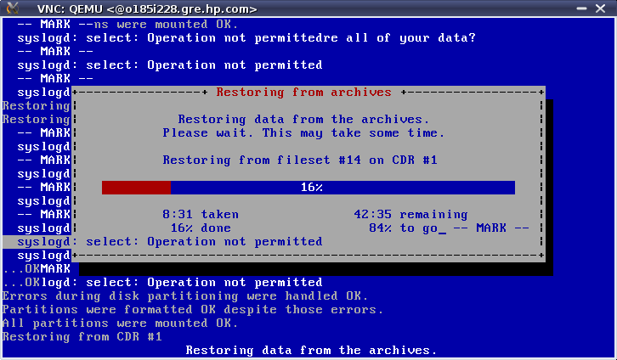
At the end of the restore process, you'll also have to adapt the disk used for the boot loader. Say yes when asked for a modified mountlist and review the content of the files proposed. Rebuild your initrd as proposed.
After that mondorestore will let you at the prompt. Review the log file /var/log/mondorestore.log, and check for potential issues at reboot time (especially boot loader).
Then close KVM/QEMU, and relaunch it without booting on the DVD:
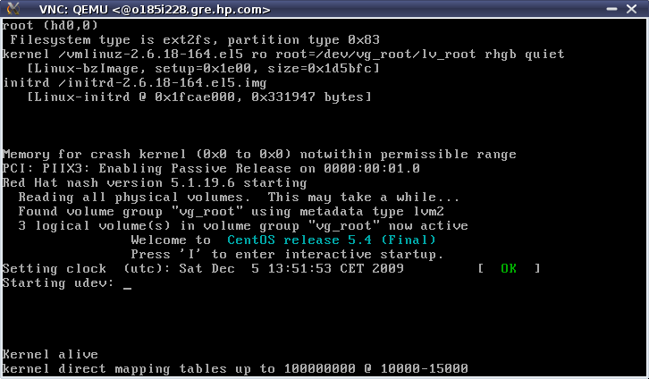
[root@localhost ~]# kvm -m 512 /home/vm/img.qemu
Network based Disaster Recovery
Estimated time: 30 minutes
Disaster Recovery (DR) Set Creation
You'll have to use the following script to realize your backup:
# mkdir -p /mondo
# cat > /usr/local/bin/postmondo << EOF
perl -pi -e 's/^HWADDR.*//' /etc/sysconfig/network-scripts/ifcfg-eth*
EOF
# mount -o rsize=32768,wsize=32768 eurolinux.gre.hp.com:/pub3/svg/mondo-test /mondo
# mkdir -p /mondo/labn
# mondoarchive -O -d /labn -p labn -g -s 4380m -N -n eurolinux.gre.hp.com:/pub3/svg/mondo-test -E /home/vm
Just replace labn above by your lab number (1 to 8). And then launch the script which will do the backup through NFS on eurolinux.
Network based Bare Metal Recovery (with PXE)
In order to restore your target blade, you'll have to populate the PXE server on eurolinux. Entries like the following have already been declared:
label lab2
kernel mondo/klab2
append initrd=mondo/ilab2 nuke load_ramdisk=1 prompt_ramdisk=0 ramdisk_size=130000 rw root=/dev/ram iso_mode pxe ipconf=eth0:dhcp prefix=lab2 nfsmount=eurolinux.gre.hp.com:/pub3/svg/mondo-test ramdisk_blocksize=1024 post=/mnt/RESTORING/usr/local/bin/postmondo serial=/dev/ttyS1 console=ttyS1
What remains to do is to create/update the kernel and initrd from your ISO image in the tftp directory. Just use the Web interface at http://eurolinux.gre.hp.com/cgi-bin/lab.cgi
then boot your target blade using F12 to activate PXE boot. At pxelinux boot prompt type labn and check the status of your restore.
SSSTK usage with Mondo Rescue
Estimated time: 5 minutes – For information only – no suitable hardware available.
Disaster Recovery (DR) Set Creation
This time, before launching the backup, look at the file /usr/share/doc/mindi-2.0.7.1/README.bkphw in order to add SSSTK support to your environment. Do it only for the Smart Array Controller.
Solve the issues linked to that installation ;-) (Hint you may need to use yum search and install additional HP Insight Manager drivers. You may even need to launch some tools manually to determine the real issue)
Use hpacucli to change the stripe size of your source blade, so that it doesn't match the one on your destination blade.
Also check in mindi log file /var/log/mindi.log, that the hardware profile has been taken in account.
Bare Metal Recovery (with PXE)
You should be questioned about the possibility to restore the hardware profile of your original Blade, in the early stages of the restore process. Confirm. Then you should have nothing special to do.
During the reboot following the restore, check that the parameter of the blade has been changed back to the value of the one originally on your source blade.

There is much more to discover around MondoRescue (, …) but I leave that for an update of this document.

