July 2009

Linux P2V migrations using MondoRescue
By Hewlett Packard
Main Writer: Lester Wade
Contributions from: René Ribaud, Gallig Renaud, Bruno Cornec
License: Creative Commons Attribution-Share Alike 3.0
MondoRescue is a backup and recovery tool for Linux, it’s packaged for various distributions and supports common architectures (i386, x86_64 and ia64). It allows online and offline backups to network storage, local disks, cd/dvd and tape. It supports a large variety of filesystems (including but not limited to ext2, ext3, ReiserFS and XFS) and partition/disk layouts (software raid, hardware raid and LVM1/2). During a restore MondoRescue will also resize partitions depending upon the new disk geometry. Those coming from an HP-UX background may liken MondoRescue to HP Ignite-UX.
The methods MondoRescue uses to archive and restore a machine means it’s well suited for use as a P2V/P2P (physical-2-virtual/physical-2-physical aka P2V/P2P) migration tool.
This document is aimed at users with a basic understanding of Linux, virtualization solutions and some familiarity in partitioning and configuring disks. It details the process for migrating a physical machine into a VMware virtualized environment. The process can easily be adapted to apply to other virtualization products such as Xen, Citrix XenServer, VirtualBox and KVM/QEMU as well as to other physical machines with different hardware components.
Migrations from HP hardware utilizing the SmartArray controller, such as ProLiant servers, will also be mentioned. This is to ensure the reader is aware of a current bug in MondoRescue and how to work around it.
This document is updated to include specific instructions relating to the migration of current distributions.
If you have suggestions on improvements for this document, you can contact me at lester.wade@hp.com.

The document is structured as follows:
Table of Contents
Linux P2V migrations using MondoRescue 1
Setting the Scene 2
Application & Key Features 3
How MondoRescue Works 3
Pre-requisites and Assumptions 3
Installing MondoRescue 4
Pre-migration Configuration 4
Archiving the server 5
Restoring the server 6
Post-Migration Configuration 10
Migrating SuSE Linux Enterprise Server 10 11
Pre-migration Configuration 11
Post-migration Configuration 12
Migrating SLES 9 and RHEL 3 13
Pre-migration Configuration 13
Post-migration Configuration 13
Migrating Debian 5.0 ”Lenny” & Debian 4.0 ”Etch” 14
Pre-migration Configuration 14
Post-migration Configuration 14
Migrating Ubuntu Server 8.04 16
Pre-migration Configuration 16
Post-migration Configuration 16
Working with LVM and the HP Smart Array controller 17
Troubleshooting 18
Summary 18
Acknowledgement 18

Setting the Scene
MondoRescue was originally developed by Hugo Rabson and a small team. Development duties have now been handed over to Bruno Cornec and Andree Leidenfrost. Bruno Cornec is the EMEA Linux Profession Lead for HP.
As the commercial virtualization solutions from vendors such as VMware, Citrix and Microsoft become more prevalent, the requirement for migration tools has increased. A company may maintain hundreds or thousands of existing physical servers which they will want move into the virtual environment rather than build from scratch. The ability to quickly and easily migrate servers is a key factor.
Effective migration tools for Linux are few and far between. Existing products which support Linux include Platespin PowerConvert and VMware Converter. Up until recently, neither of these tools supported 64bit Linux migrations.

Application & Key Features
How can MondoRescue be used? Does it meet my requirements? Does it suit my environment?
Before progressing through this document it’s worth spending time looking at the potential application of MondoRescue. The reader is probably wondering whether MondoRescue can fulfill a specific requirement and this section will outline some key features of MondoRescue to try to answer some of those questions.

Key Features:
- Network connection between target and source machine is not required. This is useful in environments where security is of key concern, a sysadmin may not want to open ports on perimeter firewalls for services such as NFS or SSH
- The archival of a system can be made onto the local disk of the source machine, DVD/CD media, USB stick or shared network volume (e.g; NFS).
- As a backup tool, MondoRescue is capable of Incremental snapshots of the source system
- The system does not need to be taken offline for archival (although it is recommended if data is volatile)
- MondoRescue will automatically resize partitions if the target machine has a different sized disk (sized by ratio new/old).
- MondoRescue is available for 32 and 64bit x86 architectures and ia64. Note that you must be migrating/restoring to the same architecture.
- MondoRescue packages are available for RedHat, Fedora, CentOS, OpenSUSE, SLES, Mandriva, Debian, Ubuntu, Gentoo, Asianux and Slackware. Source packages are also available.

How MondoRescue Works
A migration using MondoRescue consists of two steps. The first is the use of the mondoarchive utility to examine the server, group files into filesets dependant on size, archive and compress these filesets and finally to create a bootable CD/DVD containing the archive(s).
Secondly, mondorestore will repartition the disk(s) on the target virtual machine, create filesystems, restore mountpoints and unpack the archived data.

Pre-requisites and Assumptions
This document presumes the following:
- You have a 64bit (not essential for following the guide) source server running Red Hat Enterprise Linux 4 (or 5).
- Your virtualization environment is fully configured and a target virtual machine for the migration has been created and configured appropriately.
- There is network connectivity between the source machine and virtualization host
- You have access to the Internet for obtaining MondoRescue
- The target virtualization environment is VMware (server, workstation or ESX), although other products will follow very similar guidelines.
NOTE - If you're using LVM and plan to migrate from a system with different disk controllers to the destination server, you may want to look at this section.

Installing MondoRescue
Installing the latest version of MondoRescue is recommended. The example operating system used for this KB is Red Hat Enterprise Linux 4 AS. Red Hat Enterprise Linux 5 follows the same guidelines. The RPM’s can be downloaded from the MondoRescue site with the following commands (provided a direct connection to the Internet is available):

mkdir /tmp/mondo
cd /tmp/mondo
wget ftp://ftp.mondorescue.org/rhel/4/afio-2.4.7-1.x86_64.rpm ftp://ftp.mondorescue.org/rhe/4/buffer-1.19-1.x86_64.rpm ftp://ftp.mondorescue.org/rhel/4/mindi-2.0.6-1.rhel4.x86_64.rpm ftp://ftp.mondorescue.org/rhel/4/mindi-busybox-1.7.3-1.rhel4.x86_64.rpm ftp://ftp.mondorescue.org/rhel/4/mondo-2.2.8-1.rhl4.x86_64.rpm ftp://ftp.mondorescue.org/rhel/4/mondo-doc-2.2.8-1.rhel4.noarch.rpm
Installing the RPM’s is a simple case of:
rpm -ivh *.rpm
NOTE – You may find MondoRescue present in one of your distributions repositories.

Pre-migration Configuration
Prior to the migration of the physical server, it’s necessary to prepare the system for the move.
NOTE – For migrations in a production environment it’s good practice to use a temporary IP address on the source machine. This will mean users and services can’t connect to the server during the migration.
Firstly, the initrd (INITial Ram Disk) must be altered to include drivers (modules) for the LSI Logic SCSI controller. A physical machines disk controller will most likely differ from that which the virtual guest (or target machine) will use. In the case of VMware (server, workstation and ESX) the LSI Logic disk controller is emulated.
The following command will build a new initrd containing the LSI logic controller modules:
mkinitrd --with=mptspi /boot/initrd-`uname –r`-virt.img `uname –r`
An entry in the GRUB menu should be added so that once the machine is migrated, it boots using the new initrd. Duplicate the default entry and alter it:
title Red Hat Enterprise Linux AS (2.6.9-67.ELsmp)
root (hd0,0)
kernel /vmlinuz-2.6.9-67.ELsmp ro root=/dev/VolGroup00/LogVol00 rhgb quiet
initrd /initrd-2.6.9-67.ELsmp-virt.img
Ensure the new entry is the default entry.
Next, a declaration in /etc/modprobe.conf (/etc/modules.conf for RHEL 3) should be added:

alias scsi_hostadapter qla2400
alias scsi_hostadapter1 mptspi
alias eth0 e1000
You also have the possibility to do these steps after mondorestore has restored your system, just before rebooting the machine.
If your target system uses a Intel SATA controller you have to do instead:
alias scsi_hostadapter ata_piix
You should also edit the /usr/sbin/mindi file to include the disk controller modules for the target machine. Look for the FORCE_MODS line and edit:
FORCE_MODS=”mptsas mptspi”
or you can load the driver with modprobe mptspi so that mindi picks it up in the backup.

Archiving the server
The method in this section is to archive the system to a .iso image on the local disk. This requires plenty of free space depending upon the amount of data to be archived (MondoRescue doesn’t archive free space). If you have an NFS share available, you may want to archive to that.
NOTE – Make sure you’ve assigned the system a temporary IP address prior to the archive.
Presuming that MondoRescue has been installed, run the following command to generate an .iso image:
mondoarchive -O -i -N -g -d /storage -T /usr/mondo/tmp -S /usr/mondo/scratch -E “/video /junk” –s 4480m
The options are as follows:
-O This tells mondoarchive to backup
-i The -i option specifies that ISO files are to be used as the media
-N Exclude all mounted network filesystems
-g GUI mode
-d Specifies the backup device/directory, in this case it was /storage
-T Specifies the full path of the temporary directory to be used during archival
-S Specifies the full patch of the scratch directory where ISO images are built
-E Exclude these directories, /video and /junk as examples
-s The size of the ISO files, 4480m for a single sided DVD

The archival operation may take some time and depends upon how much data is to be archived. The MondoRescue GUI displays current progress.
Alternatively, running `mondoarchive` without options will run take you through the interactive GUI.

NOTE - As the archival is done live on the system, you may want to stop all processes maintaining coherent information, such as RDBMS systems for which the operation could cause a synchronisation data issue.
Once the archival is complete, copy the ISO image to the virtualization host. You could place it on a NFS share, or copy it directly to local storage:
scp /storage/mondorescue-1.iso user@virtualhost:/scratch/

Restoring the server
On your virtual host, edit the virtual machine onto which you’d like to migrate and connect the virtual CD/DVD-ROM drive – mounting the iso image MondoRescue created and that you transferred in the previous step.
Start the virtual machine and boot from the CD/DVD-ROM drive. The bootable CD/DVD image contains a small operating environment based on mindi, which builds using the kernel and initrd from the source machine during the archive process.
On Proliant servers this can also be done using the iLO (Integrated Lights Out) interface and virtual media.
When booting from the image, the following menu will appear:
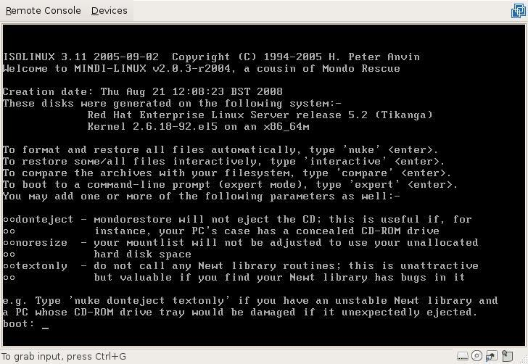Figure 1: MondoRescue main menu
Notice in figure 1 that the operating system, kernel and architecture of the system on which the disk was created is shown.
If left for 30 seconds, the MondoRescue GUI will appear prompting you to choose a function. Alternatively ‘nuke’ will run a non-interactive system restore and ‘expert’ will drop to a shell prompt.
Type ‘interactive’ and press enter. Mindi will then load a basic operating environment, using driver modules contained on the original host system (the one you archived).
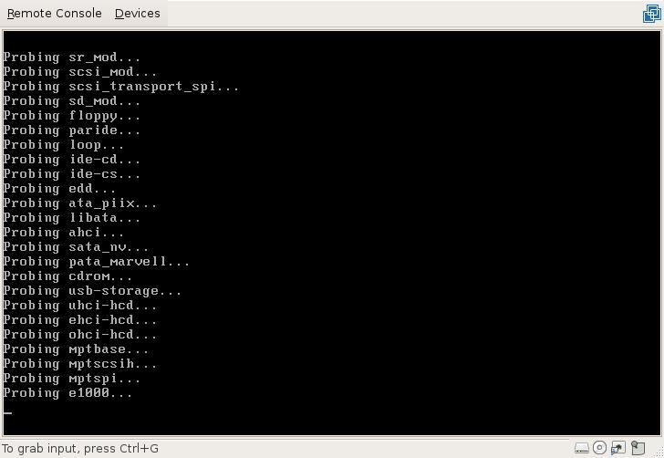Figure 2: Mindi Booting...
Figure 2 shows the Mindi environment booting, kernel modules are being loaded. Note the mpt* modules for LSI Logic controllers typically used by VMware virtual machines.
The first menu in interactive mode will ask you what you want to do. Select ‘Interactively’ to be prompted at each stage of the restore process. This will also allow you to make any necessary changes.
At the next screen, select the media from which you would like to restore. Choose ‘DVD Disks’.
The next screen will prompt you to alter the mountpoints if required.
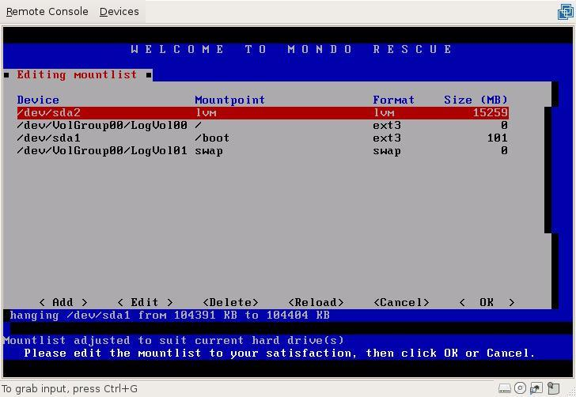Figure 3: Editing mountpoints
Figure 3 shows that MondoRescue has picked up the correct sizing for the partitions given the size of the new disk, it will alter any sizes by comparing the size of the new disk and the size of the old and altering proportionally. Check to ensure the mountpoints are correct and select ‘OK’ to proceed. Say ‘Yes’ to any warning messages if you know the mountlist is correct.
MondoRescue will then ask if you definitely want to erase and format the disks, select ‘Yes’. Once the countdown has finished, MondoRescue will begin to partition your drives.
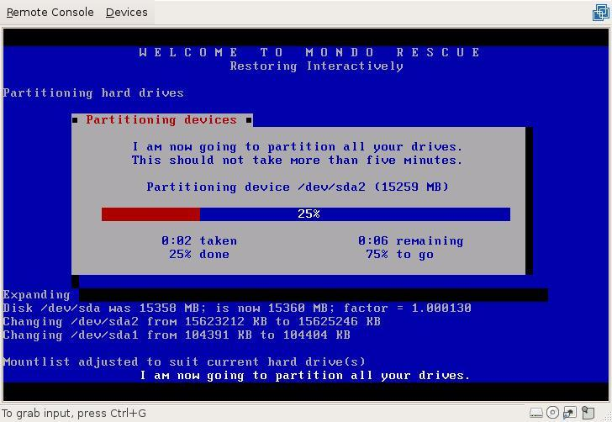Figure 4: Partitioning devices
Figure 4 shows MondoRescue partitioning /dev/sda2. In this guide, /dev/sda2 is an LVM partition so MondoRescue will also handle the creation of physical volumes, logical volumes and volume groups based on the layout of the source system.
Next, MondoRescue will format the partitions with the same filesystems used on the source machine.
Once the format is completed successfully (errors would be displayed), MondoRescue will ask whether you’d like all of your data restored. Select ‘Yes’ to begin the restoration.
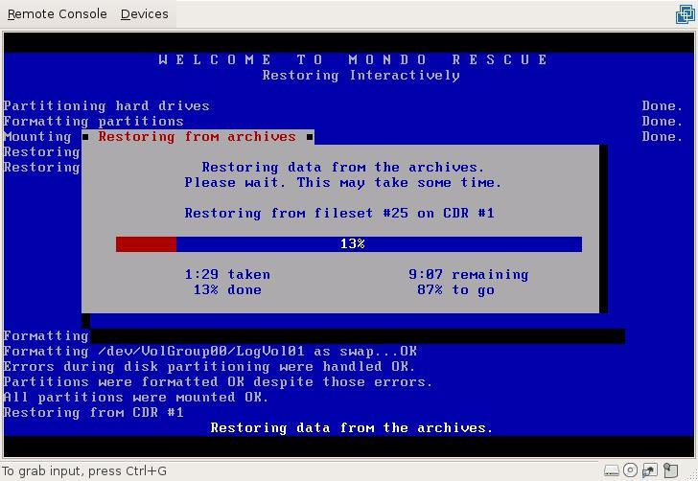Figure 5: Restoring data
MondoRescue will rebuild the file structure from the archived data. Depending on how much data was on the system and the performance of the virtual host, this can take a while. This is probably a good time to grab a coffee.
Once the restore is complete, MondoRescue will ask you whether you’d like to initialise the boot loader.
Select ‘Yes’ and select ‘No’ when asked whether you changed the mountlist or not (presuming you haven't!). Prior to rebooting the system, MondoRescue will ask one last question – whether you would like to label any partitions.
Typically a standard install of Red Hat will label the boot partition as ‘/boot’. This will then be referenced in /etc/fstab and /boot/grub/menu.lst. It’s important to ensure that the partition is relabeled correctly, else referred to by its path e.g; /dev/sda1.
By selecting ‘Yes’ to label partitions, the restore wizard will exit and drop you to a shell prompt. From here you can use the following command to check filesystem labels and relabel your /boot partition:
e2label /dev/sda1
e2label /dev/sda1 /boot
Before continuing, you may want to use your virtualization tool to take a snapshot before rebooting, in order to be able to come back to that point and fix points you may have forgotten.
Type ‘exit’ and hit return if everything looks ok. This will reboot the virtual machine.
The system should boot successfully. You’ve now migrated your physical server to a virtual server.

Post-Migration Configuration
You should reconfigure network interfaces by creating/editing/removing ifcfg-ethX files in /etc/sysconfig/network-scripts.
Conduct a set of basic tests when your configuration reflects the virtualized environment. This might include generic tests such as:
- Check that users can login
- Check partitions, filesystems and mountpoints
- Check network connectivity
- Check applications

Migrating SuSE Linux Enterprise Server 10
So far this document has covered the migration of Red Hat Enterprise Linux 4 and 5. This section will outline specifics relating to the migration of a vanilla install of SLES 10 (SP2) 64bit.

Pre-migration Configuration
Pre-requisites are afio, buffer, newt and newt-devel. Download these RPM's from the MondoRescue FTP site:
wget ftp://ftp.mondorescue.org/sles/10/afio-2.5-64.x86_64.rpm ftp://ftp.mondorescue.org/sles/10/buffer-1.19-740.x86_64.rpm ftp://ftp.mondorescue.org/sles/10/mindi-2.0.6-1.sles10.x86_64.rpm ftp://ftp.mondorescue.org/sles/10/mindi-busybox-1.7.3-1.sles10.x86_64.rpm ftp://ftp.mondorescue.org/sles/10/mondo-2.2.8-1.sles10.x86_64.rpm ftp://ftp.mondorescue.org/sles/10/newt-0.52.2-1.2.x86_64.rpm ftp://ftp.mondorescue.org/sles/10/newt-devel-0.52.2-1.2.x86_64.rpm
mtools, gcc, gcc-c++ are also pre-requisites. Download these from Novell's SLES10 yast repositories using zypper (along with dependencies):
in gcc gcc-c++ mtools
Install the afio, buffer and newt RPM's:
rpm -ivh newt-0.52.2-1.2.x86_64.rpm newt-devel-0.52.2-1.2.x86_64.rpm afio-2.5-64.x86_64.rpm buffer-1.19-740.x86_64.rpm
Then install the MondoRescue RPM's:
rpm -ivh mondo* mindi*
Now that MondoRescue is installed you can prepare the initrd with the LSI logic scsi adapter modules that will be required for the system to boot under VMware. Alter the modules depending upon your virtualisation platform.
To do this, edit /etc/sysconfig/kernel and add the modules to the “INITRD_MODULES” line. Run 'depmod' to create an updated list of module dependencies and then mkinitrd to create a new initrd with the modules included. Running mkinitrd without any options will update the existing initrd, rather than creating a new one.
depmod
mkinitrd
NOTE – Unless you specifically require the fdomain module (for certain Adaptec controllers), add fdomain to the DENY_MODS line in /usr/sbin/mindi PRIOR to archival. Failure to do so may result in your system hanging whilst booting into the restore environment.
NOTE – Unless required, specify the scsi_debug module on the DENY_MODS line in /usr/sbin/mindi. This will remove any anomalous devices when restoring within VMware and moving from /dev/hd* devices to /dev/sd* devices.
Since SP1, SLES10 has listed devices in /etc/fstab by their DeviceID. When migrating to different disks it's recommended that you alter the fstab entries to list devices by device name (e.g; /dev/sda1). You can do this manually or through the YaST partitioner:
yast disk
Select your partition(s), then select 'edit' and 'fstab options'. Then choose 'Device Name' as the identification method:
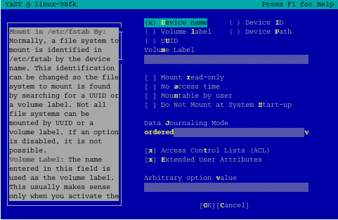Figure 6: YaST - device name labelling
You can now begin the archival of your system using mondoarchive. Follow the guidance from the previous section(s) to complete an archive.

Post-migration Configuration
Once archived you can mount the resulting iso file on the virtual machine and begin a restore. After the restore is complete, you'll need to check /etc/fstab, /boot/grub/device.map and /boot/grub/menu.lst and alter the entries in these files if required.
NOTE – If your system doesn't boot, it could be that GRUB didn't install correctly. This is a known issue and should be rectified by booting from your SLES 10 SP2 DVD image and selecting “rescue system”. Once booted and chrooted into your environment you can type: “grub-install /dev/sda” to install GRUB into the MBR of your primary disk.
Having migrated the system, your network adapter will have changed. In SLES, the easiest way to rectify this is to use YaST to delete the configuration for your old adapter and create a new one.
# yast lan
Delete the adapter configuration which is no longer present, having migrated from a DL380G5 the onboard NICs would have been Broadcom NetXtreme 2's (bnx2 module).

Migrating SLES 9 and RHEL 3
This section contains notes for those wanting to migrate SLES 9 and RHEL 3, releases based on the 2.4 Linux kernel.

Pre-migration Configuration
On RHEL 3, the following declaration in /etc/modules.conf must be added:
alias scsi_hostadapter mptbase
alias scsi_hostadapter1 mptscsih
alias eth0 pcnet32
These are device aliases for the target hardware. The VMware LSI Logic controller and AMD PCNet32 network adapter.
On SLES 9, modify the file /etc/sysconfig/kernel. Change the INITRD_MODULES section on top:
INITRD_MODULES=”scsi_mod sd_mod ext3 mptbase mptscsih pcnet32”
Continue with archival as specified in the main section.

Post-migration Configuration
For SLES 9, use yast to remove old network adapters which are no longer present and to configure your new virtual network adapter.
For RHEL 3, edit ifcfg-ethX files in /etc/sysconfig/network-scripts/ to reflect your new network configuration.

Migrating Debian 5.0 ”Lenny” & Debian 4.0 ”Etch”
This section covers specifics relating to the migration of Debian 4.0 and 5.0 systems. Debian 5.0 is referred to by example, with notes for Debian 4.0 explicitly stated.

Pre-migration Configuration
The default installation of Debian 5.0 (and 4.0) includes the MPT Fusion modules in the initrd (for LSI Logic adapters). This means regenerating a new initrd isn't necessary.
Check this is the case with the following command:
# zcat /boot/initrd-<mykernel>-server.img | cpio -itv | grep mpt
The information returned should show the mptbase, mptscsih, mptsas, mptspi modules all included.
MondoRescue depends on the following packages which you should install from Debian's apt repositories.
For Debian 5.0:
# sudo apt-get install binutils dosfstools mkisofs syslinux syslinux-common gawk parted libparted mtools afio buffer cdrecord
For Debian 4.0:
# sudo apt-get install binutils dosfstools mkisofs syslinux bzip2 gawk parted libparted mtools afio buffer cdrecord
Then download and install MondoRescue:
# mkdir /tmp/mondo && cd /tmp/mondo && wget ftp://ftp.mondorescue.org/debian/5.0/mindi_2.0.7_amd64.deb ftp://ftp.mondorescue.org/debian/5.0/mindi-busybox_1.7.3-1_amd64.deb ftp://ftp.mondorescue.org/debian/5.0/mondo_2.2.9_amd64.deb && dpkg -i *.deb
Packages for Debian 4.0 can be found at: ftp://ftp.mondorescue.org/debian/4.0/
Archive the system as defined in the main section.

Post-migration Configuration
As your network adapter will have most likely changed, you will need to edit the persistent udev rules for network adapters. This file is found in /etc/udev/rules.d, typically labelled as z25-persistent-net.rules. Open the file in your favourite editor.
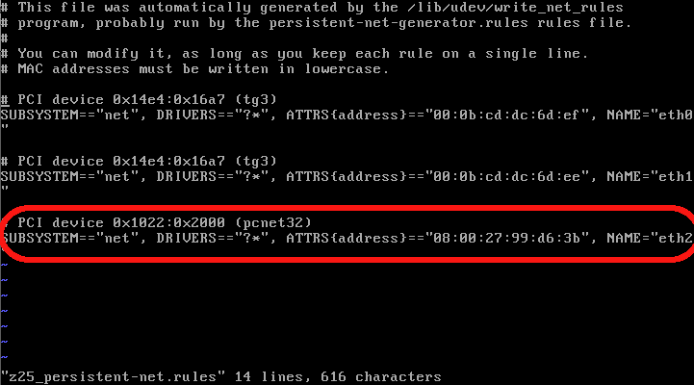Figure 7: udev network rules
The example in figure 7 shows a udev rule which has been dynamically created for the new adapter. The device name should be altered (to eth0 for example) and existing entries for redundant adapters removed.
Next, edit /etc/network/interfaces and alter the interface configuration section(s) as appropriate. In the example below the configuration now reflects the single adapter present in the demo system, eth0 (whereas previously there were two interfaces):
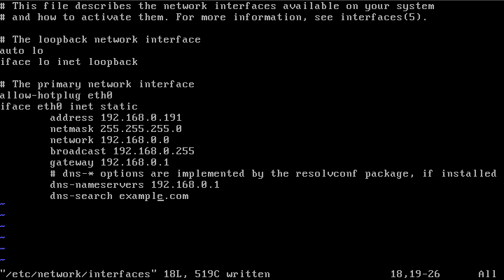Figure 8: Interface configuration
You should then go ahead and alter the rest of the system configuration to reflect it's new home.

Migrating Ubuntu Server 8.04
This section covers specifics relating to the migration of Ubuntu Server 8.04.

Pre-migration Configuration
The base installation of Ubuntu Server 8.04 includes the MPT Fusion driver family in the initrd already. You can check this with the following command:
# zcat /boot/initrd-<mykernel>-server.img | cpio -itv | grep mpt
MondoRescue is available in the standard apt repositories but is slightly out of date (version 2.2.4 at time of writing). This guide presumes you are using version 2.2.9.
Ensure the following dependencies are installed:
# sudo apt-get install afio buffer wodim binutils mkisofs syslinux gawk
Then go ahead and download and install MondoRescue:
# mkdir /tmp/mondo && cd /tmp/mondo && wget ftp://ftp.mondorescue.org/ubuntu/8.04/mondo_2.2.9_amd64.deb ftp://ftp.mondorescue.org/ubuntu/8.04/mindi-busybox_1.7.3-1_amd64.deb ftp://ftp.mondorescue.org/ubuntu/8.04/mindi_2.0.7_amd64.deb && sudo dpkg -i m*.deb
Archive the system as defined in the main section.
NOTE – By default Ubuntu 8.04 refers to partitions in /etc/fstab by uuid. You should change this to device name referencing before the name by manually changing the entries. Otherwise you will be left with erroneous entries in /etc/fstab for the old partitions.

Post-migration Configuration
After you have migrated the system, alter /etc/udev/udev.rules.d/60-persistent-net.rules and remove redundant rules for the previous network adapters. Edit the rule for the newly detected adapter and alter the device name appropriately.
Next, edit /etc/network/interfaces which controls the adapter configuration, setting IP address and network settings appropriately for your new environment.

Working with LVM and the HP Smart Array controller
If you're working with HP ProLiant's, or HP products which use the Smary Array controller (cciss module) then you're quite likely to come up against bug#183. Essentially this bug means that if you are cloning a system which uses LVM on Smart Array onto a different disk controller, LVM will not be restored correctly.
To work around this it is necessary to take the following steps:
When booting from the rescue iso, enter expert mode and configure the partitions prior to restoring in interactive mode. It’s important that all mountpoints that existed on the source machine are serviced (unless you want to retire some of them).
- Boot from the MondoRescue ISO created during archival and enter expert mode.
- Use fdisk / parted to partition the virtual disk manually.
- Create volume groups and logical volumes on the appropriate LVM partition (you should use /tmp/i-want-my-lvm as a template)
- Once the disk is prepared enter interactive mode (type ‘interactive’ at the shell prompt).
- Edit the mountlist when prompted. Ensure each mountpoint is serviced by partitions / logical volumes created in step 2 and 3. Ignore any sizing discrepancies.
- Hit ‘OK’ and DO NOT let MondoRescue partition or format your disks.
- Select ‘Yes’ when asked whether you’d like to restore all your data.
- At this point you can pick up this guide from the bottom of page 9. See the troubleshooting section below if anything happened to go wrong.

Troubleshooting
Problem 1
Attempting to log onto the migrated machine causes the user to be dumped back at the login prompt.
Solution 1
This may be an SELinux issue. Boot from a rescue CD, chroot to the mounted filesystem and disable SELinux with the system-config-securitylevel tool (Red Hat only).
Problem 2
Migrated system fails to boot.
Solution 2
Check the following; ensure filesystems are labeled as appropriate, check that the grub bootloader configuration is correct (re-install grub if required), make sure that mountpoints are correct in /etc/fstab and that the mpt* LSI Logic modules (for VMware) are included in /etc/modprobe.conf and that they exist on the system (updatedb or find / -name mptbase.ko etc.). You may also want to check to see if Mindi included them during ISO creation (see /usr/sbin/mindi).
Problem 3
Filesystems fail to mount during startup.
Solution 3
Check /etc/fstab to ensure assignments are correct. Also make sure that the volumes actually exist as expected.
Problem 4
VM boots with 'operating system not found' error message
Solution 4
There is a good chance that the bootloader is not installed properly. Install GRUB by using the 'grub-install' command. You'll need to boot into a rescue environment then mount and chroot to your root partition. The command takes the option of your disk device (e.g: /dev/sda). Once GRUB is reinstalled, check /boot/grub/menu.lst and /boot/grub/device.map.

Summary
MondoRescue is an extremely flexible tool which lends itself to many different roles. Typically used for full and incremental system backups it works equally well for the migration of servers within both physical and virtual environments. You can find out more information about MondoRescue from www.mondorescue.org.

Acknowledgement
Many thanks to the MondoRescue team in their assistance and willingness to help when I was originally assessing this method for P2V/P2P migrations.

